Items highlighted in yellow are tasks for you to complete
Items in Purple italics are help tips

Making a Résumé

Making a Résumé and application letter

Contact Information (application letter) – create this, you can use templates (see life skills web page for links) OR MAKE YOUR OWN.
The first section of your résumé should include information on how the employer can contact you. These should all be on a cover page
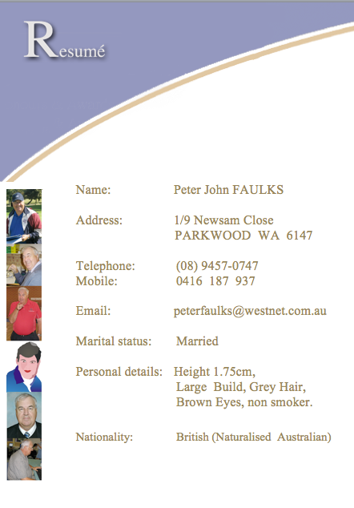
First Last Name
Street Address
City, State, Post Code
Phone (Mobile/Home)
Email Address
Web Address (if relevant)
Date of Birth
Nationality
(Photo) if appropriate)

Part of the main resume
Criteria
Copy the required criteria and match each section with your skills justifying how or why you believe you are most suitable, ensure you download the appropriate application form and look at the company on line and see if they are right for you. Be sure to highlight skills you’ve developed in each role, especially those included in the job posting. These could include…
I applied for a job and got to the interview and after the interview, I sat a test they had prepared and after all that, when I was offered the position the salary was so pathetic I could not take up the offer and realized I had wasted a lot of time and effort for no gain. Next time I will investigate the company in more depth - it does not hurt to ask the promotional opportunities or even the salary range.
- Active listening
- Communication
- Computer skills
- Customer service
- Interpersonal skills
- Leadership
- Management skills
- Problem-solving
- Time management
- Transferable skills

Hard skills are abilities specific to the job and/or industry. Generally, these are more technical skills you learn in school, certification programs, training materials or experience on the job. Hard skills might include proficiency in a particular field like language or computing.

Soft skills, on the other hand, are abilities that can be applied in any job. Often, soft skills may be referred to as “people skills” or “social skills” and include proficiency in things like: Problem solving, Leadership, Communication skills, Customer service or time management.

Objective (optional)
What do you want to do? If you include this section it should be a sentence or two about your employment goals. A customized objective that describes why you are the perfect candidate for the job can help your résumé stand out from the competition.

Career Highlights / Qualifications (optional)
(Avoid using acronyms to refer to your positions or in-house qualifications)
A customized section of your resume that lists key achievements, skills, traits, and experience relevant to the position for which you are applying can serve dual purposes. It highlights your relevant experience and lets the prospective employer know that you have taken the time to create a resume that shows how well you are qualified for the job. These could include
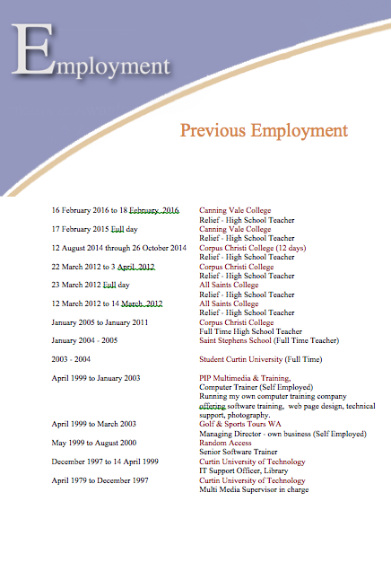
- Jobs like babysitting or mowing lawns
- Extracurricular activities, such as clubs and sports
- Sports achievements
- Internships or apprenticeships
- Volunteer work

Experience
This section of your resume includes your work history. List the companies you worked for, dates of employment, the positions you held and a bulleted list of responsibilities and achievements.

Company #1
City, State
Dates Worked
Job Title
You do not have to list (previous jobs) in a chronological format, list your skills in a functional or combined format based on your best skills for the position being offered. Your task is to get an interview!
Responsibilities / Achievements
Responsibilities / Achievements

Company #2
City, State
Dates Worked
Job Title
Responsibilities / Achievements
Responsibilities / Achievements

Education
In the education section of your resume, list the colleges you attended, the degrees you attained, and any special awards and honors you earned, always list the highest honors first.

College, Degree
Awards, Honors

Skills
Include skills related to the position/career field that you are applying for i.e. computer skills, language skills.

References available upon request
There is no need to include references on your resume. Rather, have a separate list of references to give to employers upon request.
Tip: Always ask previous or current employers for a reference, even for part time work. Ensure you have asked the person to support a reference for you.

Reference:
Name, Company, and position, Contact details, Phone:

Inserting a grave

To insert a Grave press the Option key
Plus the grave key

Then type the letter (e) to contain the grave = è

Or for other international characters press the Option key plus the letter shown then type the letter to contain the special character

For ` grave

OPTION+`
à, è, ì, ò, ù À, È, Ì, Ò, Ù OPTION+` (ACCENT GRAVE),
the letter á, é, í, ó

TIP: copy and paste special characters

